Case 4-A269-Asia-Nepal-Medicine Buddha-Bronze-1998

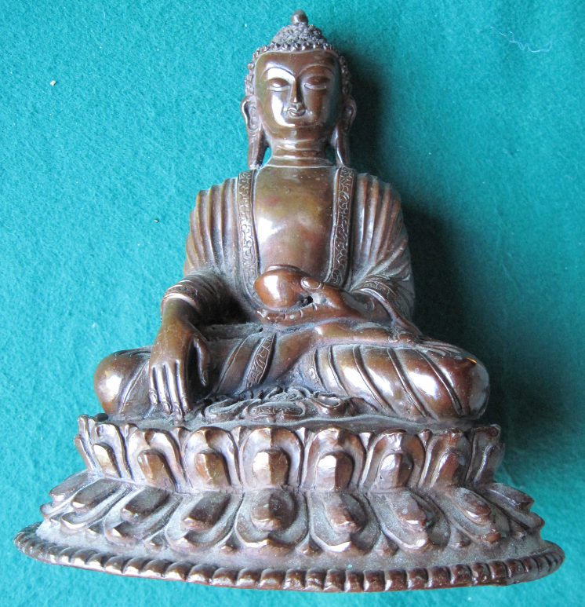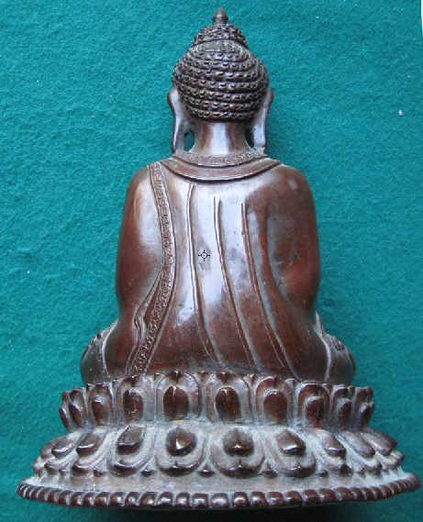 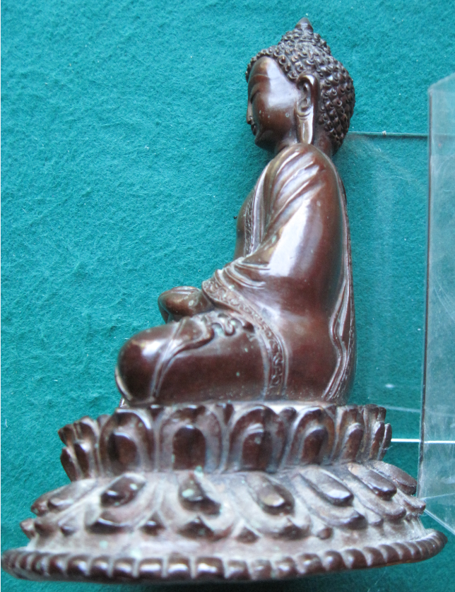

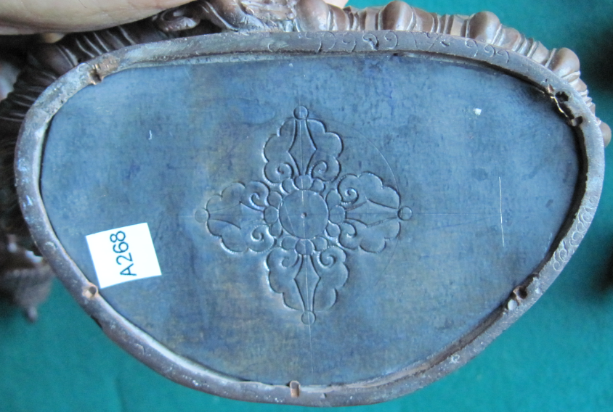

Figs. 1-4. Nepal-Medicine Buddha-Bronze-1998

**Case no.: 3**

**Accession Number: A269**

**Formal Label:** Nepal-Medicine Buddha-Bronze-1998

**Display Description:**

The Medicine Buddha is depicted with the right hand held facing downward with fingers extended toward the ground, a bowl of herbs rests in the left hand upon the lap. Tibetans believe that the Buddha delivered medical knowledge to the people of the world. The Medicine Buddha is venerated by those seeking health, and is more commonly found in the Buddhist temples and communities of Nepal and Tibet. This sculpture is an example of fine craftsmanship in producing a bronze Buddha statue showing Tibetan influences in a Kathmandu atelier, Nepal, 1998.

**LC Classification**: BQ394

**Date or Time Horizon:** 1998

**Geographical Area:** Kathmandu atelier, Nepal

**Map, GPS coordinates:**

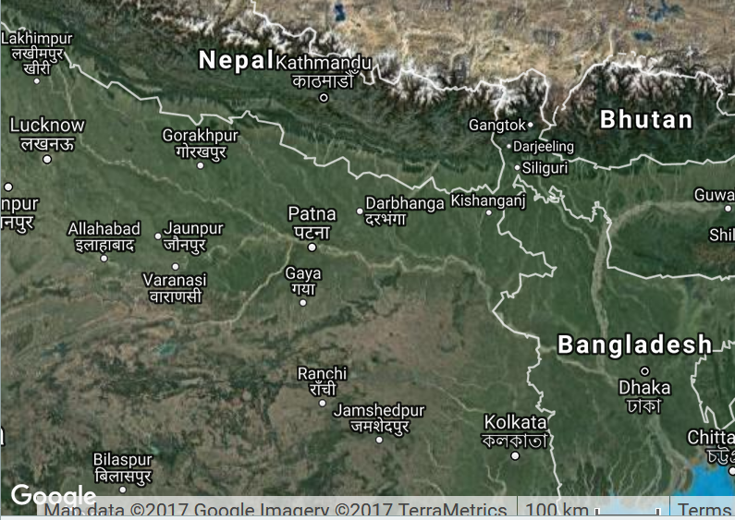

Fig. 5. Map showing Kathmandu in Nepal and surrounding countries.

**Cultural Affiliation:** Kathmandu atelier, Nepal

**Medium:** bronze

**Dimensions:** H 175.01 mm; 6.89 in

**Weight: 1061 gm; 2 lb 5 3/8 oz**

**Condition: original**

**Provenance:** Kathmandu atelier, Nepal

**Discussion:** The atelier movement in employing Nepalese youth as artists is making great headway in revitalization of Buddhism in Kathmandu valley.

**References:**

LeVine, Sarah and David N. Gellner. 2007. *Rebuilding Buddhism: the Theravada movement in twentieth-century Nepal*. Cambridge, Massachusetts; London, England: Harvard University Press.